Categorizing Values

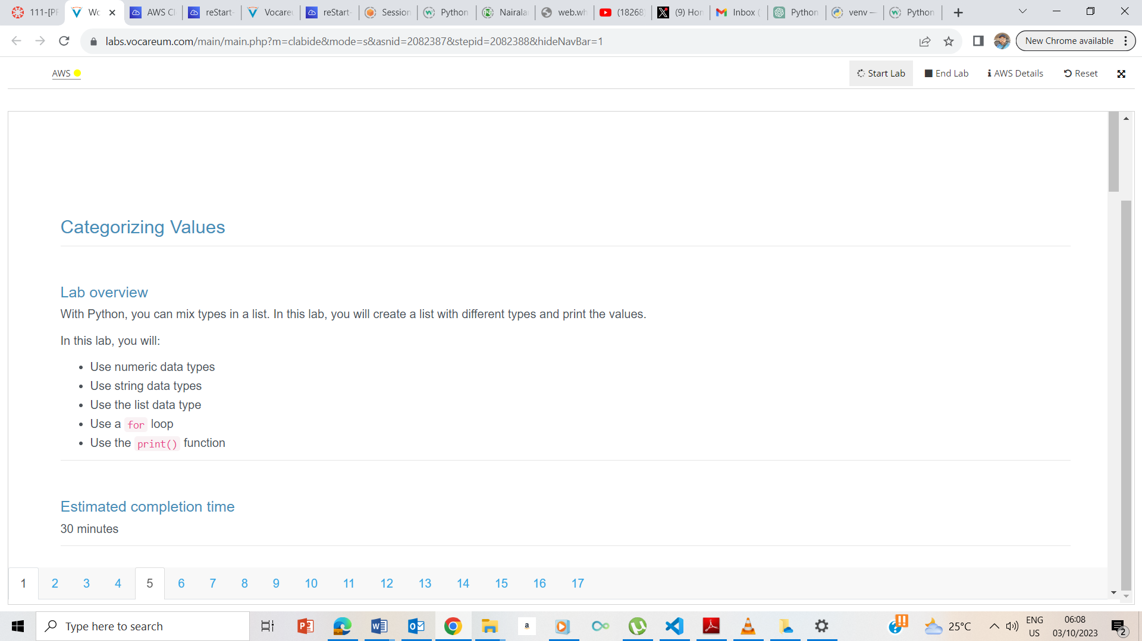

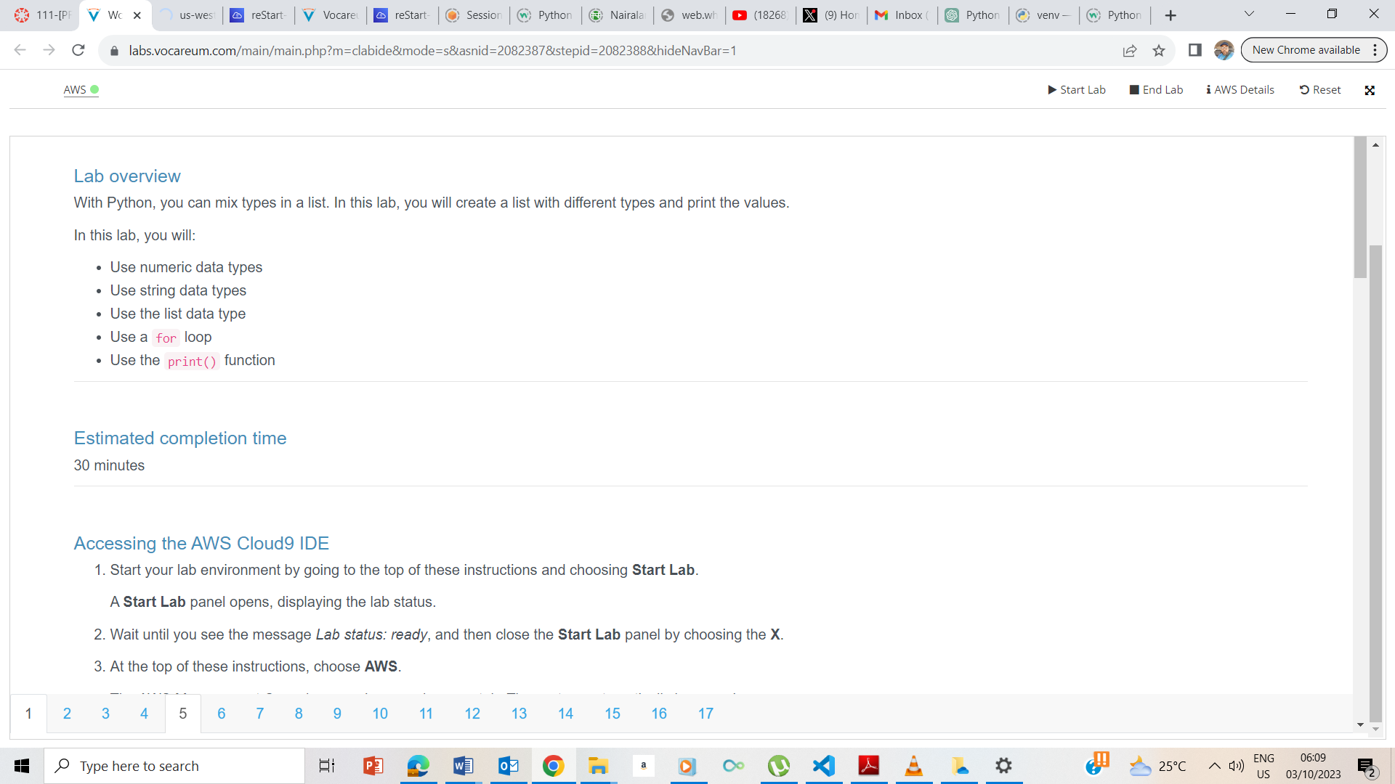

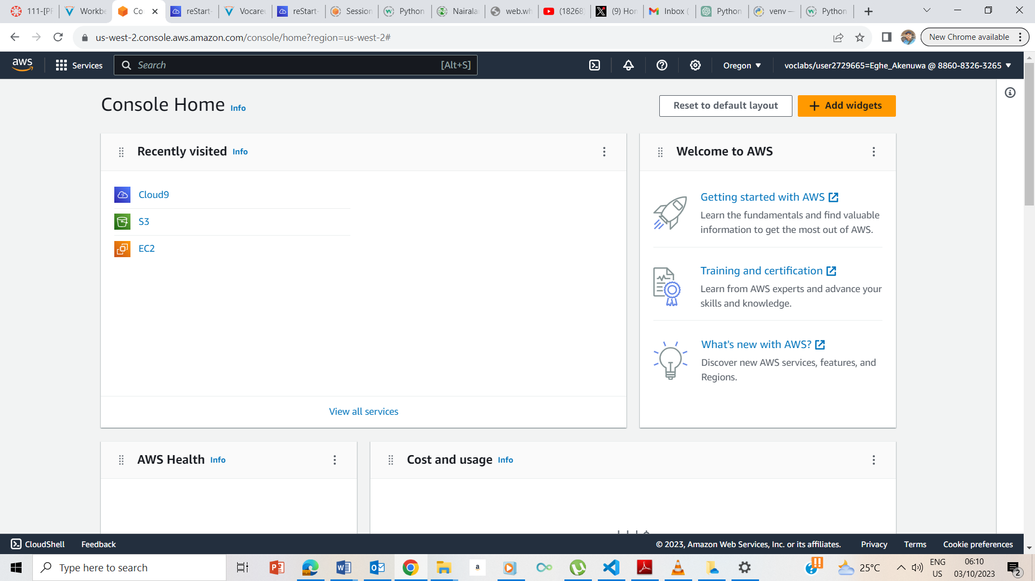

I clicked on Start, Waited for the AWS button to change from red to yellow and finally green, upon turning green, I clicked on the AWS button to take me to the AWS management Console.

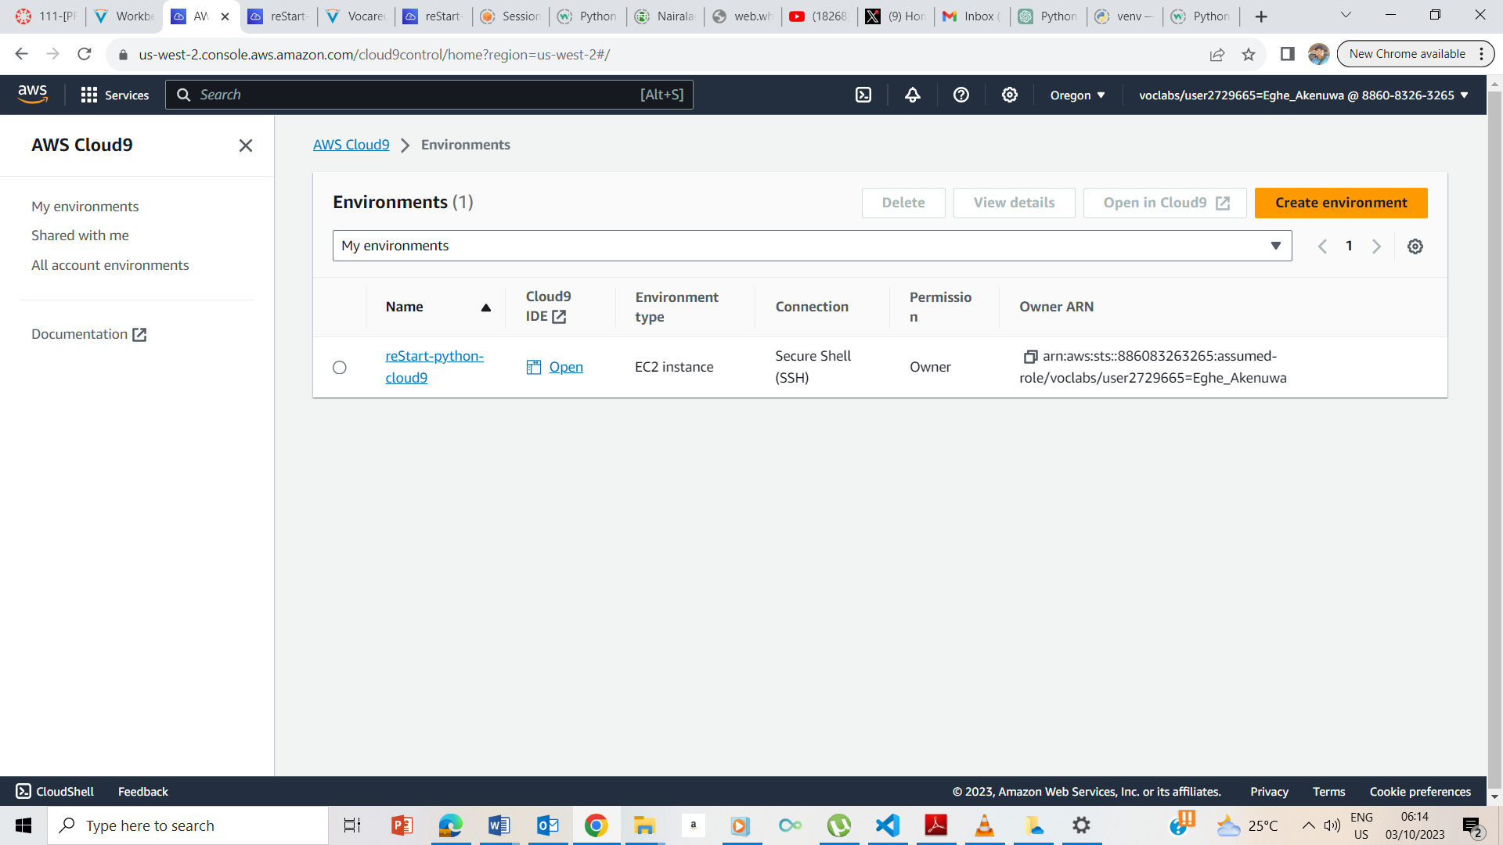

I clicked on the cloud9 to take me to the cloud9 page

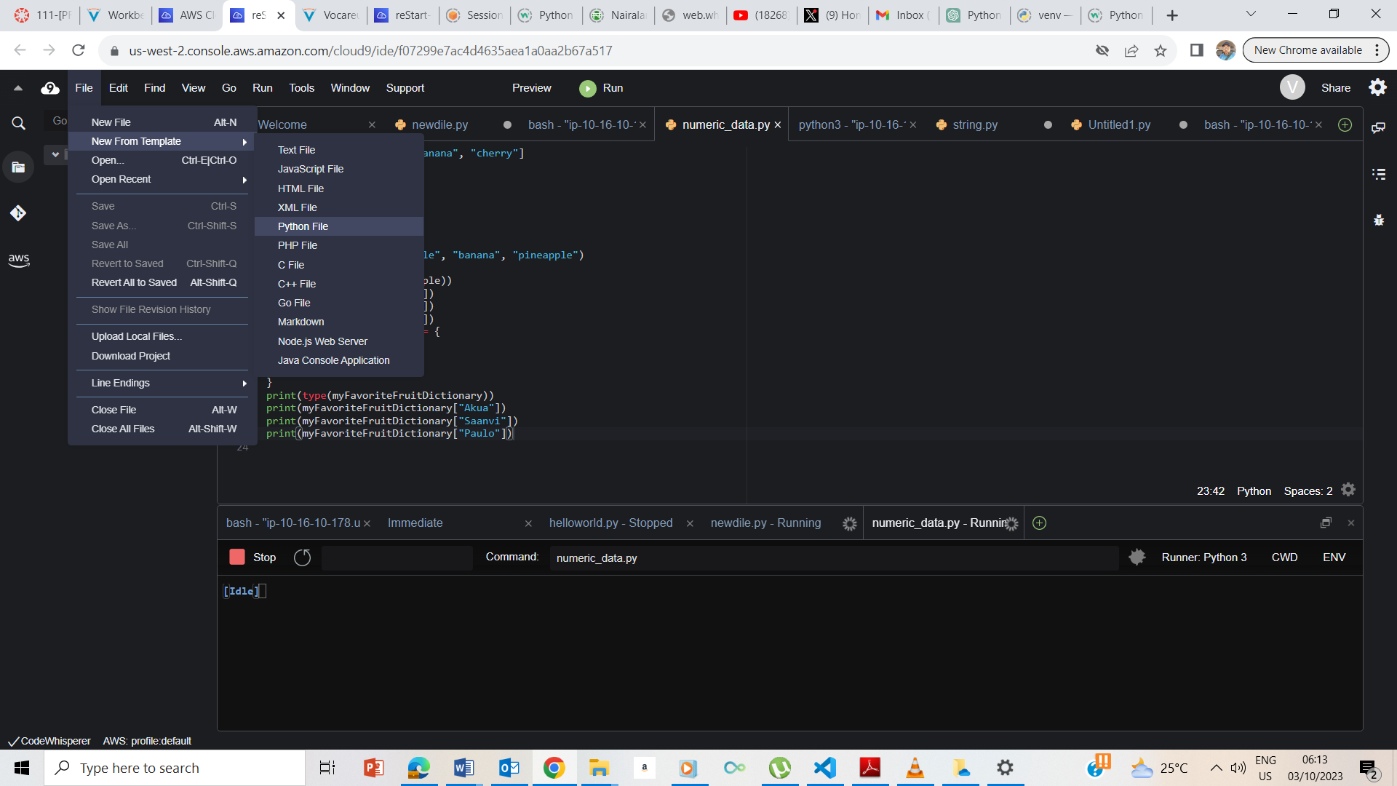

I clicked on the Cloud9 IDE open to take me to the page and I now clicked on file to open from template to python.

## **Creating your Python exercise file**

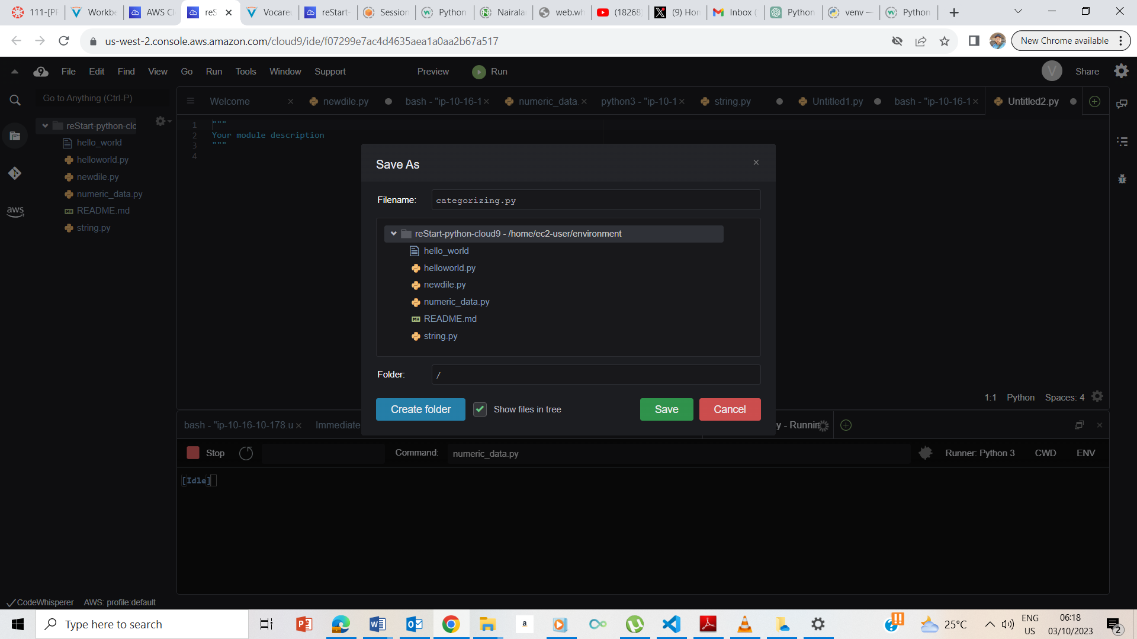

I saved the file

## **Accessing the terminal session**

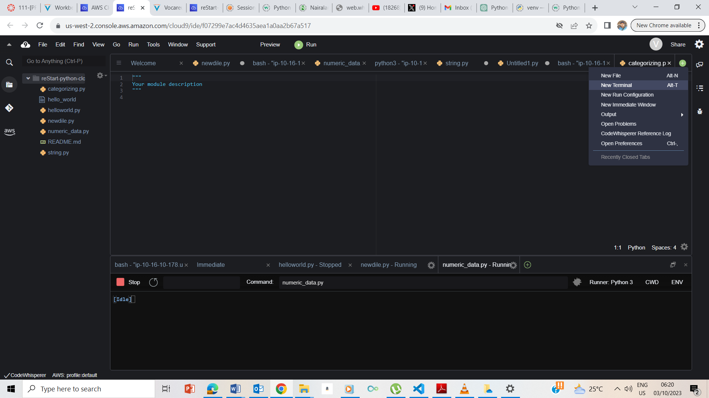

Created a new terminal

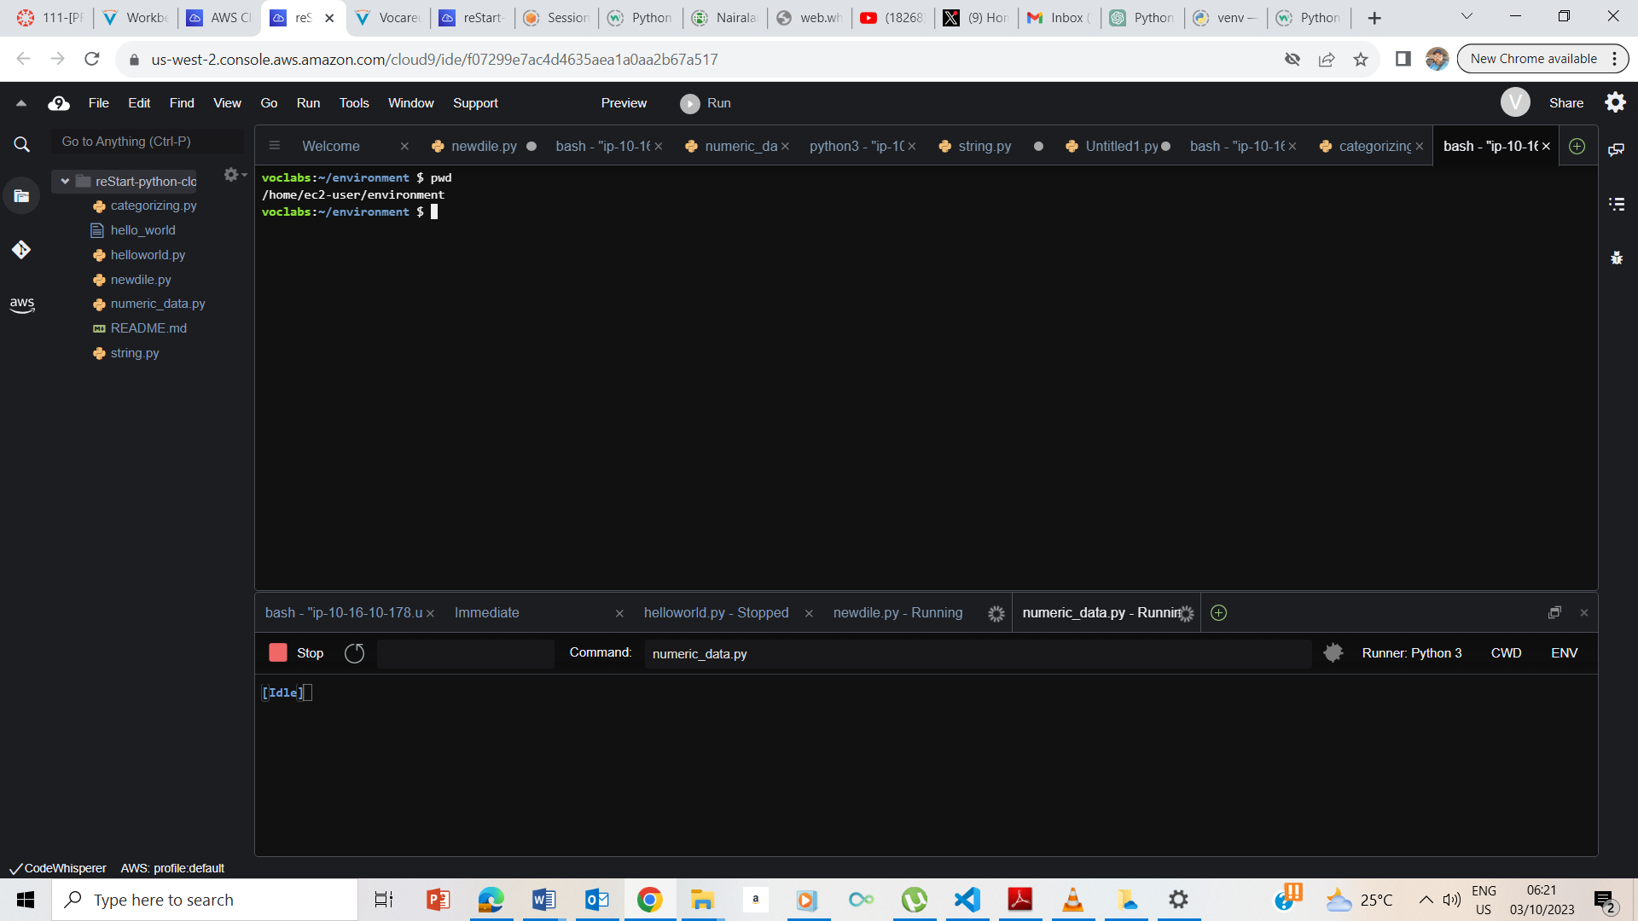

I entered pwd to take me to ec2-user/environment

## **Exercise 1: Creating a mixed-type list**

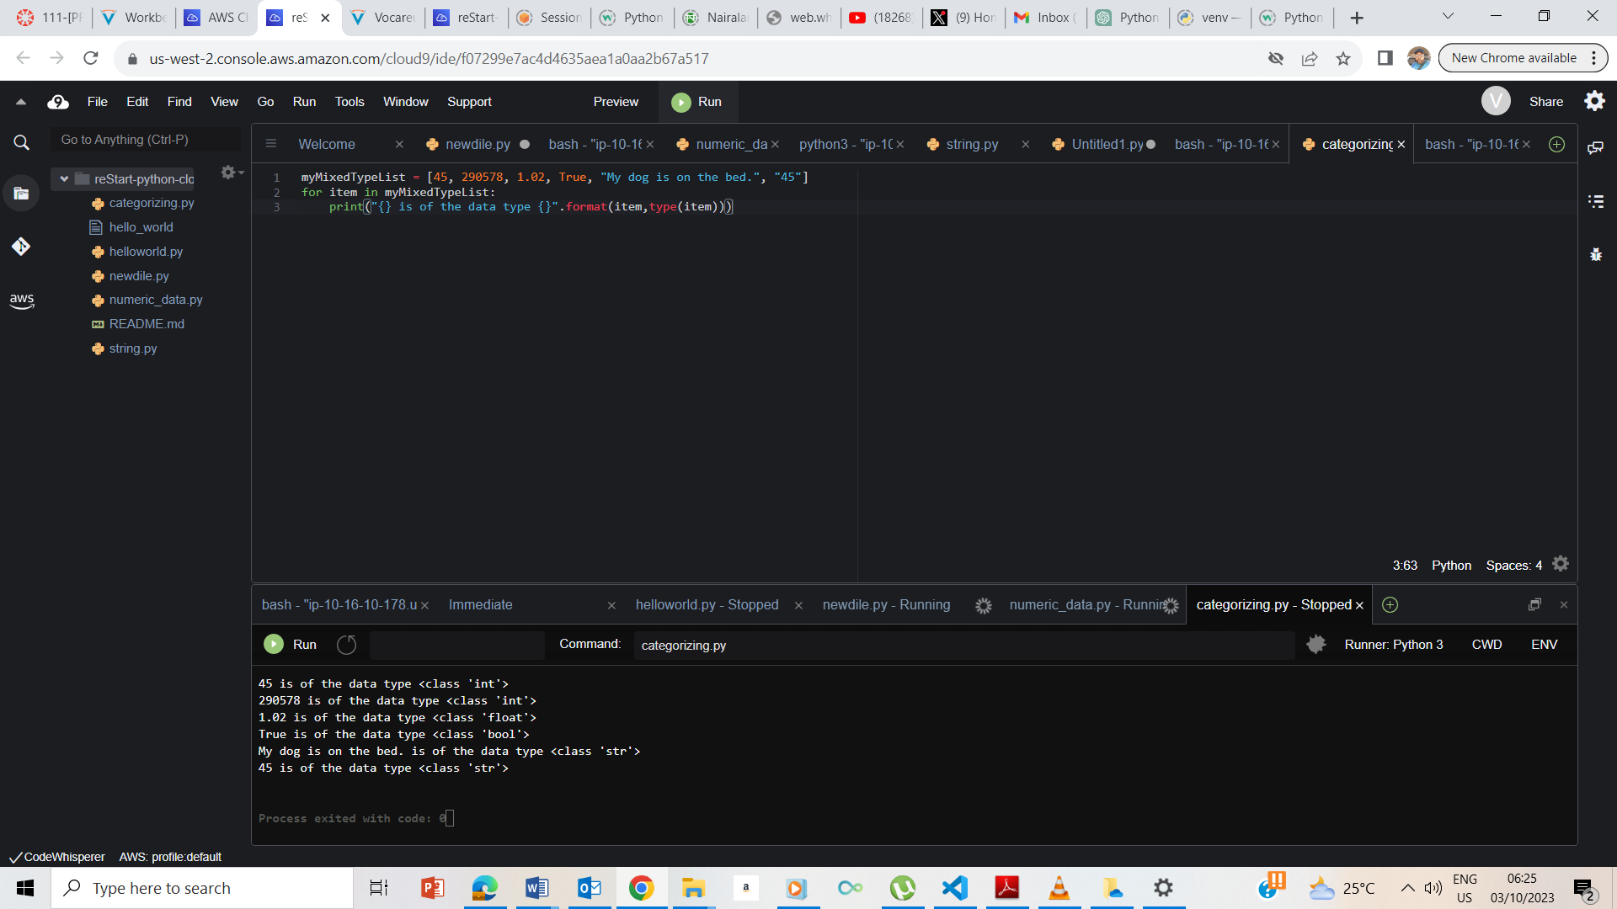

I entered the code as instructed and the code ran as expected.

## **End Lab**

